
Question: What are the best shower chairs for elderly individuals in the UK?

Answer: The Freeway Shower Chair Seats, such as the Horseshoe Seat and Aperture Seat, are excellent options for elderly users. They are designed with comfort, safety, and ease of use in mind. These chairs provide sturdy frames, adjustable features, and non-slip components, making them ideal for elderly individuals who may require extra support during bathing.

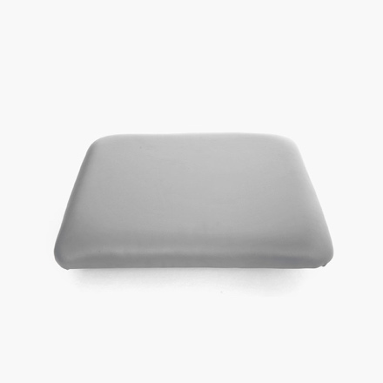
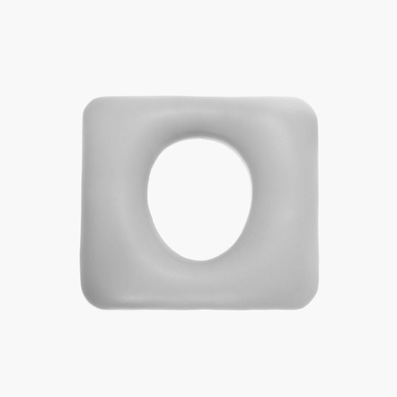
Contact us for more information and pricing.


